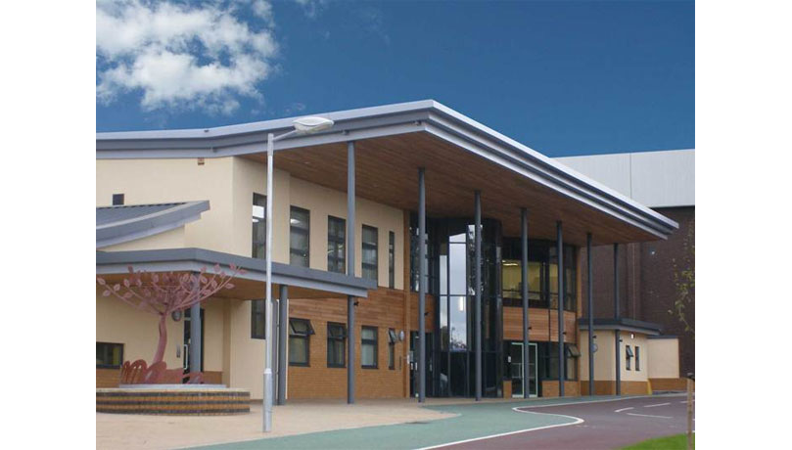

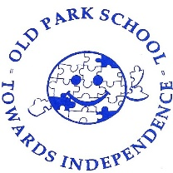

Careers Policy

September 2024

Date of Next Review: September 2025

Person Responsible: Mrs A Croft

Old Park School

Careers Curriculum Policy - ‘My Future…The Road Ahead’

Intent

At Old Park School we recognise that it is important to enable our students’ personal development through careers, employability and enterprise education, incorporating learning careers, local labour market information, the local offer, future planning and self-expression. Careers Education, Information, Advice and Guidance (CEIAG) forms an integral part of student life at Old Park School. We want to encourage all students to consider a broad range of careers and pathways that are right for them and use contacts from the world of work, further education, and social care to help them understand where different choices can lead them in the future. With the varied needs of our learners in mind we refer to our Careers offer as “My future, the road ahead,” acknowledging the need for a full range of opportunities to be planned for, not simply paid or supported employment.

Our duty is to secure independent careers guidance for all Year 7-14 pupils. It is intended that we will expand on this advice and guidance, so they are inspired and motivated to fulfil their potential. We help every student develop high aspirations and consider a broad and ambitious range of options. Inspiring every pupil through more real-life contacts with the wider community can help them understand where different choices can take them in the future.

Through close collaboration with partners like Connexions, the Careers and Enterprise Company (CEC) and the West Midlands Combined Authority we provide face-to-face advice and guidance to build confidence and motivation. This includes consideration of the role that careers professionals can play in supporting pupils as one element of a varied careers programme. All students attending Old Park School have an Education, Health and Care Plan (EHCP). As part of the consultation towards these documents we fulfil the requirement to work with local authorities to identify vulnerable young people, including those with special educational needs and those at risk of not participating post-16, and the services that are available to support them.

Our careers curriculum is designed and regularly reviewed to meet the differing needs and requirements of our pupils. This is developed throughout pupils’ time at school and is always supportive of their abilities, strengths and skills. In line with our Pathway model, the following vision statements identify aspirational outcomes for individuals in terms of their career (the road ahead).

*Pathway 1*

“I am cared for by people who understand my individual needs, including my health needs. I may be in a social care setting each day. I have access to enrichment opportunities to engage me in the wider community.”

*Pathway 2*

“I may attend a specialist college or receive a social care package. I am supported by people who understand my needs and encourage me to express my own preferences and make positive choices. I have access to enrichment opportunities to engage me in the wider community.”

*Pathway 3*

“I may attend either a specialist college or mainstream college with specialist provision. I may access day centres as part of a social care package or spend time with a PA. I am an active citizen and benefit from regular access to community facilities with the support I need.”

*Pathway 4*

“I may attend mainstream college with specialist provision. I may be working towards entering supported employment, independent living, an apprenticeship, or further training. I may attend a day centre or go out with a PA as part of a social care package. I am an active citizen and will regularly access community facilities. I may engage in independent travel.”

*Pathway 5*

“I may be attending a mainstream college with specialist provision. I may be working towards entering supported employment, independent living, an apprenticeship or further training. I will be accessing local facilities with the support I need, which may include travelling independently.”

Implementation

The careers programme is designed to build upon student’s experiences over time, whist adhering to the requirements of the Gatsby Benchmarks. In some instances, these Benchmarks have been met in the most relevant way available to our students, as whilst we want to aim for aspirational outcomes for all learners, it is important to ensure that realistic targets and opportunities are presented to our young people and their families. The specific annual coverage of the programme can be found in the ‘Careers Programme- September 2024’ document.

Impact

The impact of our Careers Programme can be seen through a variety of sources. Our destination data is held for 3 years, allowing us to monitor whether the placement taken by the student in in keeping with the aspirational outcome identified by their pathway vision statement (see ‘Intent’).

In order to ensure our careers programme is fit for purpose and in line with National guidance we assess it through termly review of Gatsby Benchmarks using the Compass plus auditing tool. This is supported by an Enterprise Co-ordinator, Nathan Hutchinson.

Compass plus is also used to keep systematic records of any Careers activities undertaken by the students; taking into consideration individual attendance data and cross referenced against the Gatsby Benchmarks addressed.

Our STEM Medium Term Sequences of Learning demonstrate where Careers information is integrated into the curriculum throughout the school, alongside more specific careers education learning activities in the Secondary Phases. Offsite learning Educational visit records also indicate where classes have engaged in Employer encounters, and are to be recorded on the Compass plus tool as part of each student’s individual monitoring.

Our Personal Provision Plans for students in Year 10 and above are categorised in line with the Preparing for Adulthood headings, to allow for targets to be specifically tailored towards the future goals and aspirations of individuals. Our EHCP reviews also include a Preparation for Adulthood section for these older students, identifying longer term goals to be worked towards.

Student’s own contributions in terms of their wishes and feelings regarding their future targets and EHCP review, alongside their responses to their Transition visits and interactions with potential future placements will support us as a school to identify more successful strategies and areas for development, or a need for additional networking to take place.

Our ePEP meetings for Secondary age Looked After Children (LAC) now include a section for Careers education, where an individual’s experience and the opportunities given in relation to Careers education can be recorded and monitored against the relevant Gatsby Benchmarks.

Work Experience reports from offsite placements and onsite Work Related Learning projects will be used to demonstrate individuals strengths, achievements and areas for development.

Following the Autumn Careers and Transition event held at the school each year, feedback is sought from students, families, employers/providers and staff. Further feedback from all these stakeholders will be sought as part on an annual review process in the Summer term each year, to allow for adaptations and developments to be made as needed.

*Old Park School understands the importance of safely obtaining and storing personal data and is committed to following all aspects of UK General Data Protection Regulations (GDPR).*

*All information gathered and held in respect of this policy will be protected in line with current General Data Protection Regulations and the Data Retention Policy*.

Amy Croft

September 2024